Melting Rate & Snow Density
Science: Snow Experiments
Experiment 1: Melting Rate (Salt vs No Salt)
Question: Does salt make snow melt faster?
You will compare how quickly snow melts with and without salt.
Steps:
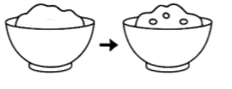
Collect two equal amounts of snow in separate bowls.
Sprinkle salt on one bowl. Leave the other plain.
Start timing and observe which melts faster.
Prediction: Which bowl will melt faster? Why?
Observation Table:
 | Snow with Salt | Snow without Salt
Time (mins)

Why it works: Salt lowers the freezing point of water, so snow melts faster when salt is added.
────────────────────────────────────────────
Experiment 2: Snow Density & Water Content
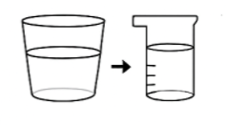
Question: How much water is in snow?
You will measure the amount of water after snow melts.
Steps:
Fill a clear container with snow and mark the level.
Let the snow melt completely.
Measure the water level and compare to the original snow level.
Prediction: How much water do you think will remain?
Observation Table:
Snow Level (cm) | Water Level (cm)

Why it works: Snow is mostly air, so the water level after melting is much lower than the snow level.

