Bus Information
110 Times and Route
General Bus Information
- Make sure that you have read the Heritage Code of Conduct for bus travel and ensure that follow this on every journey.
- Arrive at the bus stop in plenty of time- Five minutes before your bus is due to arrive.
- Ensure that you have your bus pass ready. No bus pass means no travel. If you lose your bus pass you will need to apply for a new one at Student Services; the current cost of a replacement pass id £5.
- Find a seat and stay sat down until you reach your destination (either school or your home bus stop)
- If you are the only student at the bus stop remember your put out your hand so that the bus driver knows that you want to catch the bus.
- At the end of the day please queue up in school in the allocated place for your bus queue, these are at Performance, Communication and Social blocks (you will be shown where these are).
- You can only catch the bus that you have been allocated. Trying to get onto another bus could mean a health and safety risk to you and other students due to overcrowding.
- If you are unsure of anything, ask either another student or any member of staff.
Bolsover Market Place
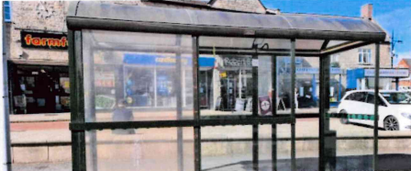
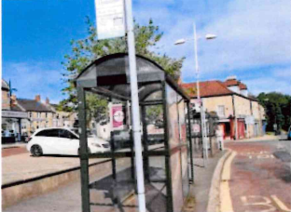
Arrival: Approximately 07:35am

Bolsover Hilltop Road (opposite Mill Lane)
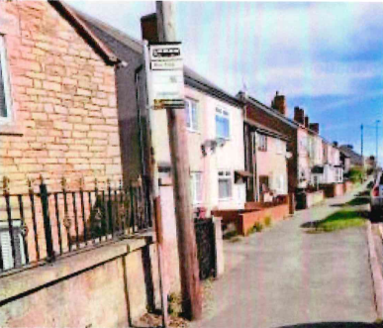
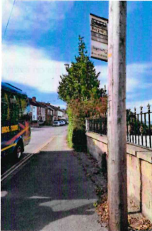
Arrival Approximately: 07:40am

Shuttlewood Road Crossroads
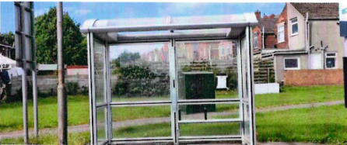
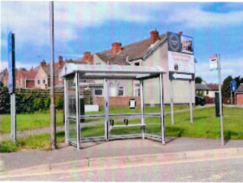
Arrival: Approximately 07:45am

Mastin Moor Crossroads
Arrival: Approximately 07:50am
Hague Lane, Renishaw (Opposite Carrwood Road)
Arrival: Approximately 07:55am
Balborough, Sheffield Road (Opposite Clifton Avenue)
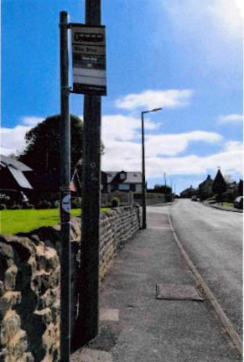
Arrival: Approximately 08:00am
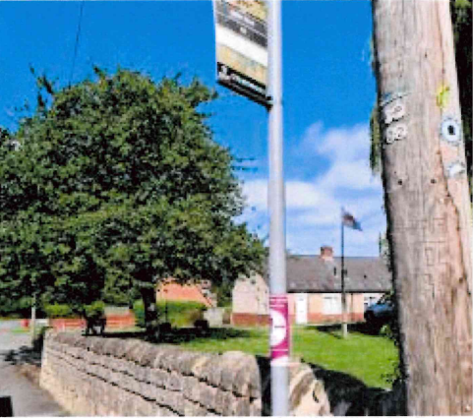

Clowne Road (Opposite the Crescent)
Arrival: Approximately 08:05am
*Paid for service – details on out of catchment letter

